# **Project HCHQ**

(09-03)

**Written Report**

Boston Tan(2P1 2)

Euston Tan(2P1 22)

Justin Wen(2P1 24)

Zhou Yan(2P1 30)

Hwa Chong Institution

**Category 9**

**(Infocomm)**

# **(1)Table of Contents**

1. **Table of Contents—--------------------------------------------------------------------2**
2. **Introduction-–---------------------------------------------------------------------------3**
   1. **Thesis Statement—------------------------------------------------------------3**
   2. **Rationale—----------------------------------------------------------------------3**
   3. **Objective—----------------------------------------------------------------------3**
   4. **Target Audience—-------------------------------------------------------------3**
3. **Literature Review—--------------------------------------------------------------------4**

**a. Introduction To Gamefication—--------------------------------------------4**

**b. Effects on Learning Outcomes—--------------------------------------------4**

**c. Learning Process and Understanding—-----------------------------------4**

**d. Motivation, Interest and Engagement—-----------------------------------4**

**e. Perceptions of Students and Teachers**---------------------------------------**5**

1. **Methodology-----------------------------------------------------------------------------3**
   1. **Ideation—------------------------------------------------------------------------6**

**b. Needs Analysis------------------------------------------------------------------6**

* 1. **Work Distribution—----------------------------------------------------------8**
  2. **Timeline—----------------------------------------------------------------------9**

**5. Overview —-------------------------------------------------------------------------------10**

1. **Implications and Recommendations—---------------------------------------------11**
2. **Conclusion—-----------------------------------------------------------------------------12**
3. **Annex—------------------------------------------------------------------------------------13**
   1. **GitHub—-------------------------------------------------------------------------13**
4. **References—------------------------------------------------------------------------------14**

# **(2)Introduction**

## 

2a: Thesis Statement

HCHQ is an interactive game that aims to allow students to learn History in a fun and interactive manner, enabling students to enjoy their lesson and understand more about the history of their school.HCHQ is a game mainly based on Hwa Chong Institution(HCI)

2b: Rationale

Students find it hard to listen in History classes due to a lack of engagement. Students will not focus during lesions and often get distracted.Thus students will not be able to learn history as efficiently. This tool will also allow teachers to teach the students without the need to develop their own resources which allocates more time for the teachers to do other tasks.

2c: Objective

Our objective is to enable teachers to teach students in a fun manner, one that is beneficial to the students too. Our game plans to allow students to be more engaged in lessons through an increase of interaction.

## 2d: Target Audience

Our game is targeted towards students of Hwachong and members of the public. Our game is made so that they can learn more about our school in a fun manner that will leave an everlasting memory, letting them be aware of the rich history Hwachong has.

# **(3)Literature Review**

**3a: Introduction to Gamification**

Gamification refers to the integration of game elements such as points, leaderboards, and rewards—into non-game contexts, especially education. Gamification typically aims to enhance student engagement, motivation, and comprehension. Tools such as Kahoot!, Minecraft: Education Edition, and Classcraft have enabled students to actively participate in gamified classroom tasks that align with curriculum objectives.

### **3b: Effects on Learning Outcomes**

Research shows that gamification positively influences several areas of historical education. These areas include the learning process, understanding of material, motivation, student engagement, and perceptions of both teachers and learners.

### **3c:Learning Process and Understanding**

Gamification enhances the learning process through Digital Game-Based Learning (DGBL), which merges instructional design with interactive game environments. A prominent model, DGBL-ID, includes stages such as design, implementation, and evaluation. Game narratives and immediate feedback help students retain historical knowledge more effectively.

Students also demonstrate improved understanding of historical material through games that incorporate storytelling, missions, and simulations. The use of the Gamification Modeling Language (GaML) further refines educational game development to align with pedagogical goals.

### 

### **3d: Motivation, Interest, and Engagement**

Gamified history learning boosts student motivation by offering fun and competitive elements. Historical games, such as those simulating ancient kingdoms, make historical figures and events more memorable and relatable. These platforms also promote active participation, collaboration, and creativity among students.

Engagement increases when students take on roles, complete tasks, and work as teams in classroom simulations. Feedback systems and points encourage emotional self-regulation and cooperative problem-solving.

### 

### 

### **3e:Perceptions of Students and Teachers**

Teachers report that gamified assessments are more effective and enjoyable than traditional methods. They observe increased student participation and satisfaction. Students, on the other hand, appreciate clear instructions, visible progress, and collaborative activities. Learning becomes a shared and immersive experience that deepens historical inquiry.

# **(4)Methodology**

**4a:Ideation**

Based on the literature review exploring gamification as well as the surveys we conducted and the available tools, we were inspired to develop a platform where students and teachers alike are able to unlock a deeper understanding of our school and Singapore’s history

through gaming.

**4b: Needs Analysis**

We surveyed some people in Hwa Chong asking if they found lessons boring and not engaging.(Refer to Fig 4.1) In our survey, about 90% of people found the lessons boring.

We also asked if students enjoyed Quizzes which a large majority of students said yes.(Refer Fig 4.2)We also asked what they think is the most engaging between 3 options; A game, a quiz or a typical day to day lesson that we students should be quite familiar with. In our survey, majority chose a game.

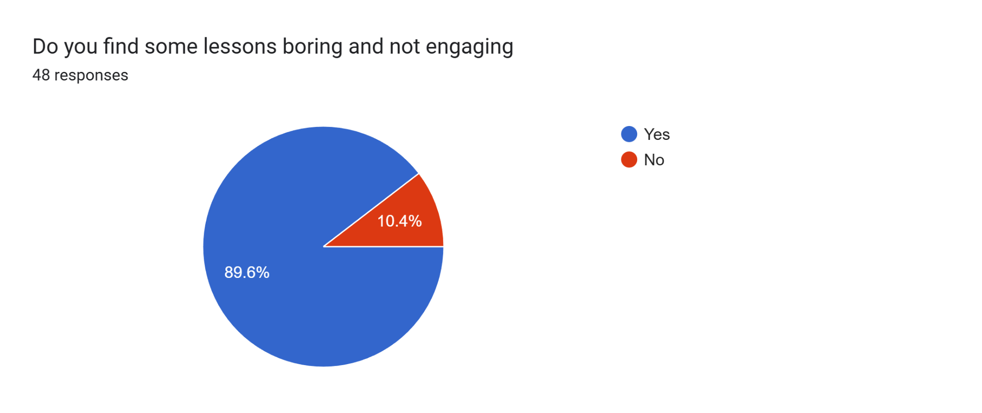

Fig 4.1

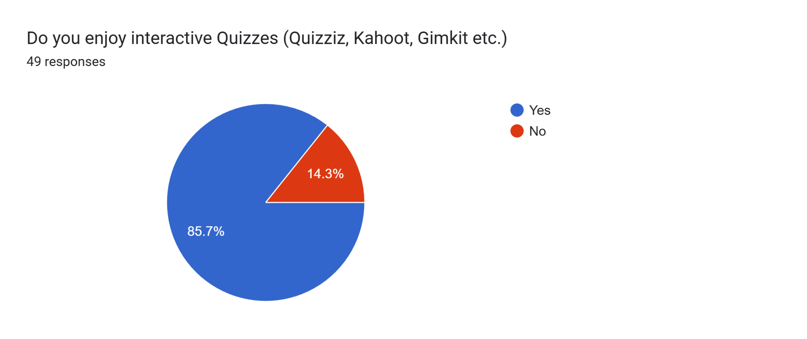

Fig 4.2

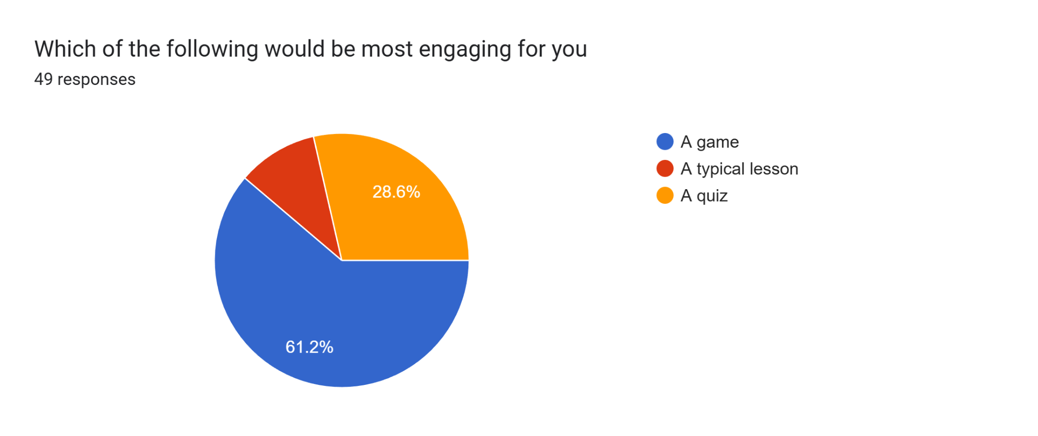

Fig 4.3

**4c:Work Distribution**

| **Name** | **Role** | **Description** |
| --- | --- | --- |
| **Euston Tan** | Main Coder/ Researcher/Ideator | -Codes with assistance from others  -Responsible for distribution of tasks and supervision of progress  - Research History to provide points for Game Questions  -Comes up with questions for game  -Tester |
| **Boston Tan** | Designer/ Coder | -Focuses on designing the map  -Coding of the map  -Tester |
| **Justin Wen** | Music / Coder | -Works on music of different areas  -Coding of music and map  -Creates characters in game  -Tester |
| **Zhou Yan** | Slides designer | N/A |

**(4d)Timeline**

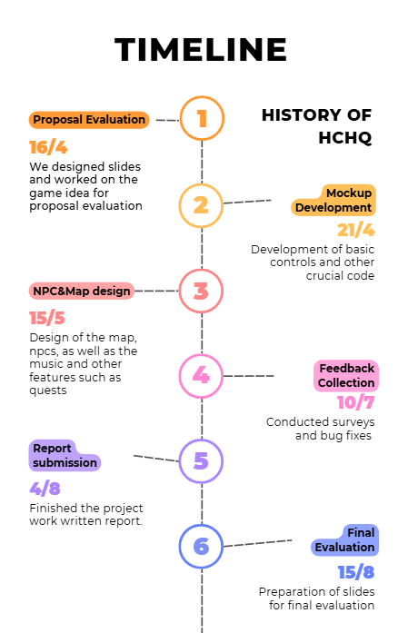

Fig 4C

# **(5)Overview**

We use Gamemaker Studio to develop the game. Our game is a RPG (Role-Playing Game) which allows students to freely explore and complete quests to complete the game. We decided to go for a retro style as it suits our history game theme. The game works by having the student move it around with the “W,A,S,D” Keys. Students can also communicate with student leaders or school leaders to learn more about history.Since Gamemaker Studios allows us to design everything by ourselves, we are able to make the game as realistic as possible while suiting our selected 8 bit pixel game aesthetics.

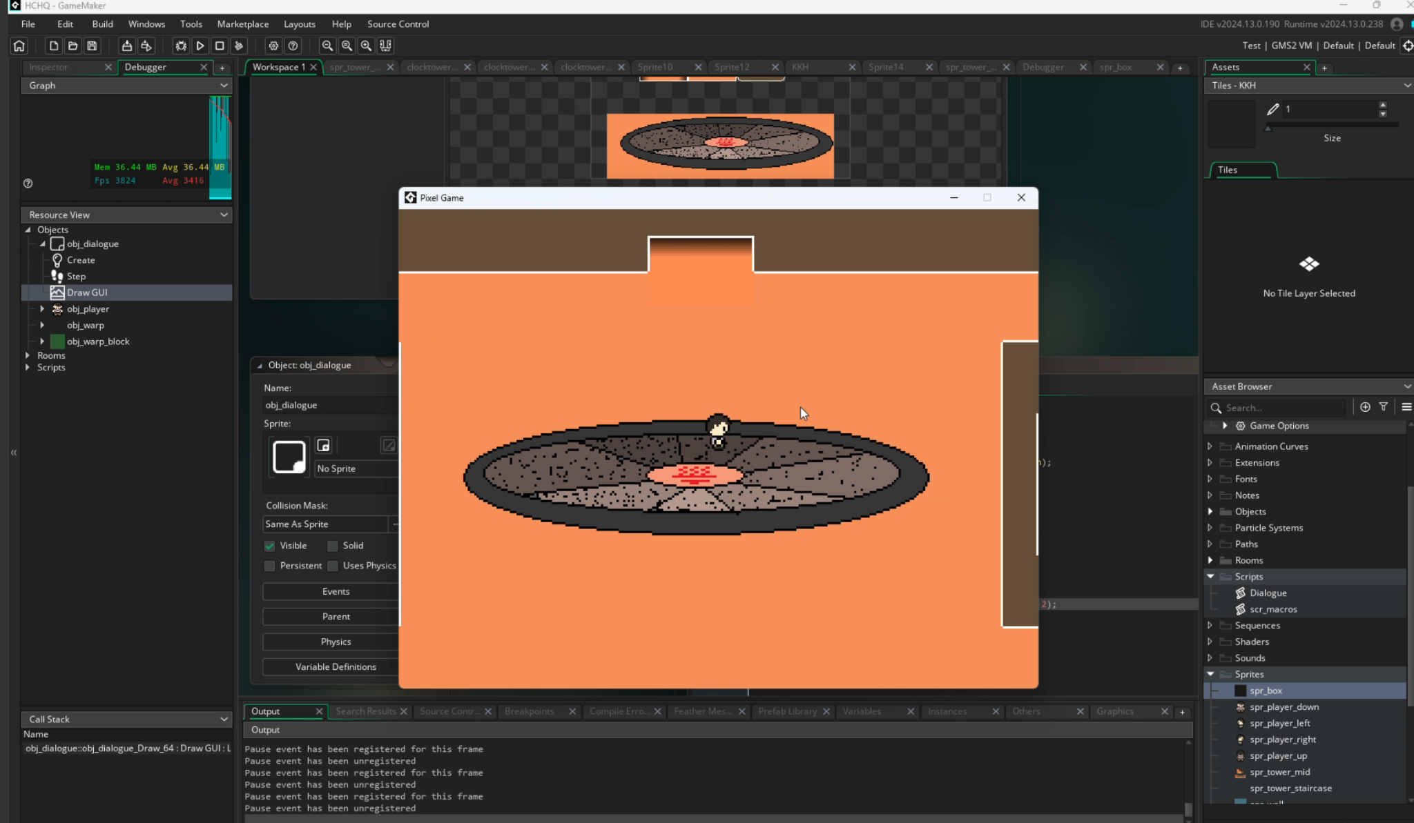

Fig 5a

# 

# **(6) Implications and Recommendations**

# 

# 

HCHQ is fully functional and highly effective in serving its purpose of providing students with an interactive and enjoyable way to learn about the history of Hwa Chong Institution through a game-based approach. The platform successfully improves student engagement and helps them better understand the school’s rich heritage while supporting teachers with ready-made resources. However, there are a few limitations:

* The game content is currently focused mainly on textual information, which may not fully capture students’ interest in a visual and auditory manner.
* Some students may find certain questions repetitive, reducing replay value.
* The current system lacks personalization features that adapt to different students’ learning paces or prior knowledge.

As such, we hope to expand our project and include these features in the future:

* We can implement more multimedia elements, such as voice narration or video clips, to enrich the learning experience and better illustrate historical stories.
* We can develop a question randomization or adaptive difficulty system to maintain student engagement and improve replay value.
* To further personalise learning, we can introduce progress tracking and achievement badges, motivating students with recognition and allowing teachers to better monitor their students’ progress.

Overall, these improvements will help us further support the objective of engaging students in learning Hwa Chong’s history while making the experience more memorable, enjoyable, and educational.

# **(7)Conclusion**

In an educational landscape where student engagement is key to meaningful learning, HCHQ stands out by uniquely combining historical education with interactive gameplay. Our immersive platform allows students to explore the rich history of Hwa Chong Institution through fun and engaging quests, while also supporting teachers by providing a ready-made educational tool.

The journey of developing HCHQ was not without its challenges. We encountered difficulties in designing intuitive gameplay that balances both educational value and entertainment, as well as ensuring that the user interface remained accessible for all age groups. Despite these hurdles, our team remained committed, sharpening our problem-solving abilities and fostering a spirit of collaboration. We learned the importance of thoughtful design, clear communication, and adaptability throughout the development process.

This experience not only strengthened our technical and creative capabilities, but also deepened our understanding of how gamification can be a powerful tool in education. We hope that HCHQ will reshape how history is taught and remembered—making it both meaningful and enjoyable for generations of Hwa Chong students and the wider community.

# **(8)Annex**

**7A:Github**

We use GitHub on our computers to allow us to share files and work with one another online without having to download or upload constantly. All code can be found in our GitHub.

<https://github.com/ProjectWork-Infocomm/HCHQ>

# **(9)References**

We referenced :Gamification in History Learning: A Literature Review By Oka Agus Kurniawan Shavab, Leli Yulifar, Nana Supriatna, Agus Mulyana. It is published by Atlantis press. As the original is a PDF, this is a version of it in Google Docs:<https://docs.google.com/document/d/1XUhMj7W2cRL6Rcrkm9XB30cvYggxZbGVdsSLuwzNZB4/edit?usp=sharing>

Original Website:<https://www.atlantis-press.com/proceedings/icess-21/125961164>